# IT 140 Design Document Template

## Instructions

Fill out the sections below. Be sure to remove the bracketed text before submitting your Design Document.

Randy Marcelino

## Storyboard (Description and Map)

Hey, young Padawan we are under attack from the Sith and we need your help! We need to prepare ourselves to defeat Palpatine in the throne room of the Deathstar. We will need a lightsaber to fight from the war room, beskar armor to protect ourselves from the armory, droids to learn about Palpatine from the tech room, a jet pack to evade attacks from the storage room, Yoda to guide and assist us in the battle he is in the council room and the Millennium Falcon from the hangar to fly to the Deathstar.

This is the map of the Jedi base to assist you on your journey:



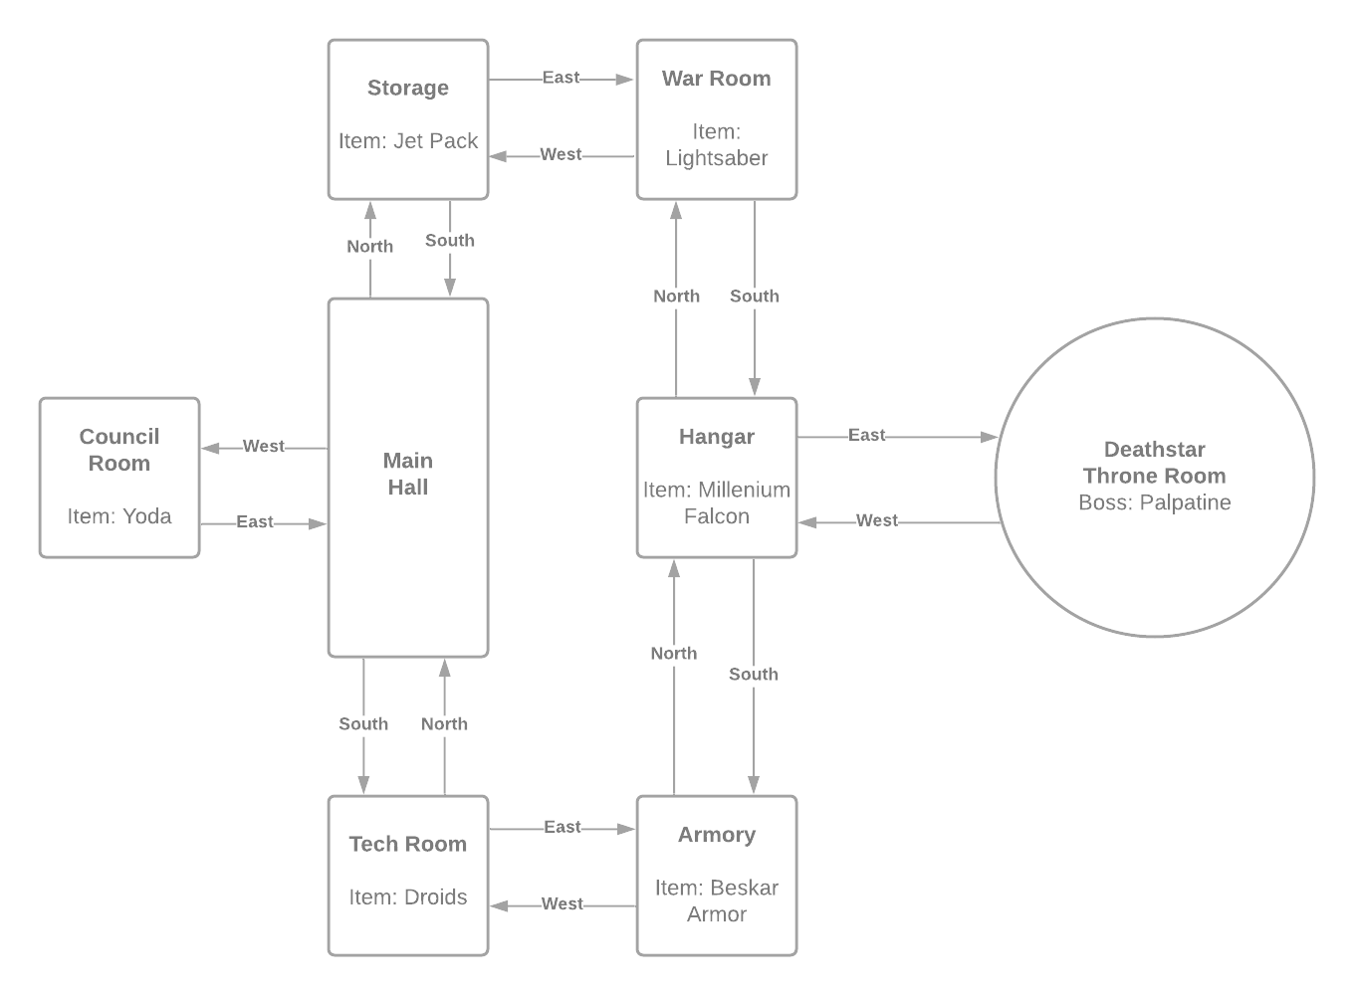

## Pseudocode or Flowchart for Code to “Move Between Rooms”

# Required input from the user to move needs to contain a direction and an action.

# An example of the requested user input would be “Go East” or “Go West”.

# Ask the user to put in command as “Enter Command:”.

DEF move_player(direction)

IF room to direction exist

move player to direction

PRINT(new room info)

command = ask next user input

ELSE

PRINT(error no room to direction)

command = ask next user input

PRINT(current room detail)

command = get user input and change its case to all lower or upper

WHILE boss not slain

IF command.FIND(“GO EAST”) != -1

move_player(east)

ELIF command.FIND(“GO WEST”) != -1

move_player(west)

ELIF command.FIND(“GO NORTH”) != -1

move_player(north)

ELIF command.FIND(“GO SOUTH”) != -1

move_player(south)

ELSE

print(command cant be executed)

command = ask next user input

## Pseudocode or Flowchart for Code to “Get an Item”

print(room information)

# Take in user commands for what to do such as “Take Lightsaber” or “Take Droids”.

# Ask the user for input as “Enter Command:”.

command = user input turned to lower or upper

# Get room item from current room in list.

room_item = item in room player is currently in

WHILE boss not slain

IF command.FIND(room_item) != -1

PRINT(item achieved message)

place item in bag

PRINT(display room information)

command = ask next user input

ELSE

PRINT(item not in this room)

PRINT(display room information)

command = ask next user input